
Faculty of Science

Course: CSCI 2040U: Software Design and Analysis
Assignment: #2
Topic: Design and implementation

Overview
In this assignment, we’ll complete the design for a case study, and implement the result. Before you begin, form a group of either 2 or 3 students.

Instructions
Below is a class diagram for part of a navigation system. The class called MathUtils contains a number of mathematical functions. The system could be used by a global positioning system (GPS) to locate various objects, including the GPS user. Most objects are stationary, because their location has been previously recorded. GPS users, on the other hand, are moving at a particular orientation and velocity. The system could be used to determine the estimated travel time to reach a stationary object.

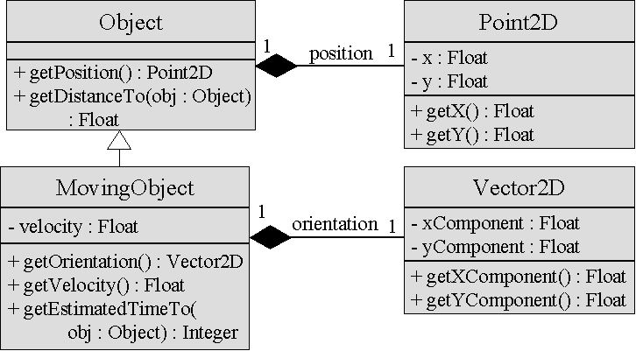

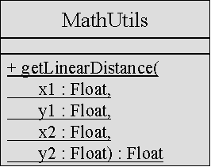

- For this question, you can assume that the method called ‘getLinearDistance()’ defined on the MathUtils class is written, and it returns the distance between the points (x1,y1) and (x2,y2). Write pseudo code and draw a collaboration diagram for the method ‘getDistanceTo()’ on Object.
- Using the method defined in the previous question, write the pseudo code and draw the sequence diagram for the method ‘getEstimatedTimeTo()’ on MovingObject. Remember the formula d = vt from grade 9 math? The time to travel distance ‘d’ at velocity ‘v’ should take ‘t’ seconds, or d/v. The method is called ‘getEstimatedTimeTo()’ because a MovingObject’s velocity (or orientation) might change during transit. You may, however, assume that the orientation is always directed toward the destination object.
- Using Java or C++ (for another language, confirm with the instructor), implement the first four classes. The MathUtils class is shown below. Also below is a driver class that you can use to test your classes. Do not implement any more functionality than is necessary to make the driver program work. Since Java has a class called Object already, call the Object class GPSObject. It may also make sense to rename the MovingObject class GPSMovingObject.

public class MathUtils {
public static float getLinearDistance(float x1, float y1,
float x2, float y2) {
return Math.sqrt((x2-x1)*(x2-x1) + (y2-y1)*(y2-y1));
}
}

How to Submit
Export your word processing document to Word or PDF format, if necessary. Please name your file using the pattern Assignment2_2040_Smith_Alhasan_Chopra.pdf. Submit the document to Blackboard in the corresponding drop box for this lab assignment. You can show your completed work to the TA for marking, but you should still submit your file to Blackboard for posterity.

import java.util.Random;

class Asmt2Driver {
public static void main(String[] args) {
Random rg = new Random();

double x = rg.nextDouble() * 10;
double y = rg.nextDouble() * 10;
Point2D pos1 = new Point2D(x, y);
float vel1 = rg.nextFloat();
x = rg.nextFloat() * 10;
y = rg.nextFloat() * 10;
Vector2D ori1 = new Vector2D(x, y);
GPSMovingObject obj1 = new GPSMovingObject(pos1, vel1, ori1);

x = rg.nextFloat() * 10;
y = rg.nextFloat() * 10;
Point2D pos2 = new Point2D(x, y);
float vel2 = rg.nextFloat();
x = rg.nextFloat() * 10;
y = rg.nextFloat() * 10;
Vector2D ori2 = new Vector2D(x, y);
GPSMovingObject obj2 = new GPSMovingObject(pos2, vel2, ori2);

int time = obj1.getEstimatedTimeTo(obj2);
System.out.println("It took " + time + " seconds for "+obj1+" to reach "+obj2+".");
}
}

